**04 - TGV**

Reference TGV with sin·cos normal creation in a 2pix2pi domain.

u = U_0*cos(X).*sin(Y);

v = -U_0*sin(X).*cos(Y);

w = u*0;

P = P_0 + rho_0.*(U_0*U_0/4).*(cos(2*X) + cos(2*Y));

T = P./(rho_0*R_specific);

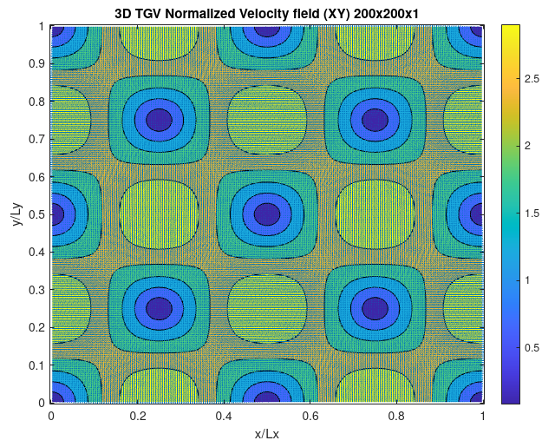

1. **Spatial order of accuracy**

Results should show order 2, for mesh with lower than 50 grid points the order was ~1. However with mesh >50 Ngrid points results turn up to be the expected second order. In fact, they show ~1.8, but if 50 grid point is removed, the order is exactly 2. Time step was fixed to 2e-5 for all simulations to keep CFL always below 0.3 at least, hence avoiding unstabilities.

u2 L2 norm error = 0.0748 0.0251 0.0064 for 50,100 and 200 respectively.

Hence doing the ratio of first 2 gives 2.98, however on last 2 the error is reduced 3.921 (2^4) as expected.

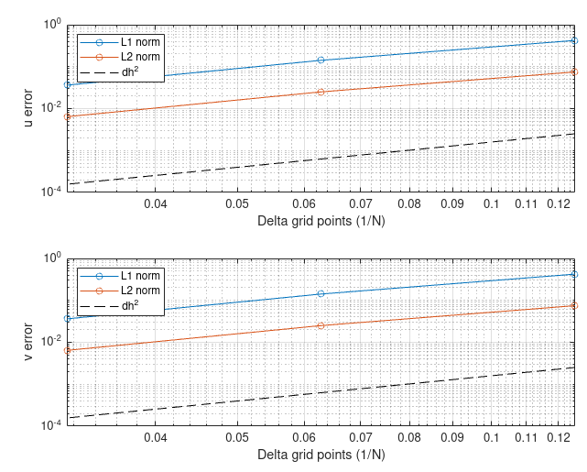

1. **Validation with exact solution**

